**Exercise 1: Control Structures**

**Scenario 1:** The bank wants to apply a discount to loan interest rates for customers above 60 years old.

* + **Question:** Write a PL/SQL block that loops through all customers, checks their age, and if they are above 60, apply a 1% discount to their current loan interest rates.

**Program:**

BEGIN

EXECUTE IMMEDIATE 'DROP TABLE Loans';

EXCEPTION WHEN OTHERS THEN NULL;

END;

/

BEGIN

EXECUTE IMMEDIATE 'DROP TABLE Customers';

EXCEPTION WHEN OTHERS THEN NULL;

END;

/

CREATE TABLE Customers (

CustomerID NUMBER PRIMARY KEY,

Name VARCHAR2(100),

DOB DATE,

Balance NUMBER,

LastModified DATE

);

CREATE TABLE Loans (

LoanID NUMBER PRIMARY KEY,

CustomerID NUMBER,

LoanAmount NUMBER,

InterestRate NUMBER,

StartDate DATE,

EndDate DATE,

FOREIGN KEY (CustomerID) REFERENCES Customers(CustomerID)

);

INSERT INTO Customers (CustomerID, Name, DOB, Balance, LastModified)

VALUES (1, 'John Doe', TO_DATE('1985-05-15', 'YYYY-MM-DD'), 1000, SYSDATE);

INSERT INTO Customers (CustomerID, Name, DOB, Balance, LastModified)

VALUES (2, 'Jane Smith', TO_DATE('1990-07-20', 'YYYY-MM-DD'), 1500, SYSDATE);

COMMIT;

INSERT INTO Loans (LoanID, CustomerID, LoanAmount, InterestRate, StartDate, EndDate)

VALUES (1, 1, 5000, 5, SYSDATE, ADD_MONTHS(SYSDATE, 60));

COMMIT;

BEGIN

FOR loan_rec IN (

SELECT l.LoanID, l.InterestRate, c.DOB

FROM Loans l

JOIN Customers c ON l.CustomerID = c.CustomerID

) LOOP

IF MONTHS_BETWEEN(SYSDATE, loan_rec.DOB) / 12 > 60 THEN

UPDATE Loans

SET InterestRate = InterestRate - 1

WHERE LoanID = loan_rec.LoanID;

END IF;

END LOOP;

COMMIT;

END;

/

SELECT * FROM Loans;

**Output:**

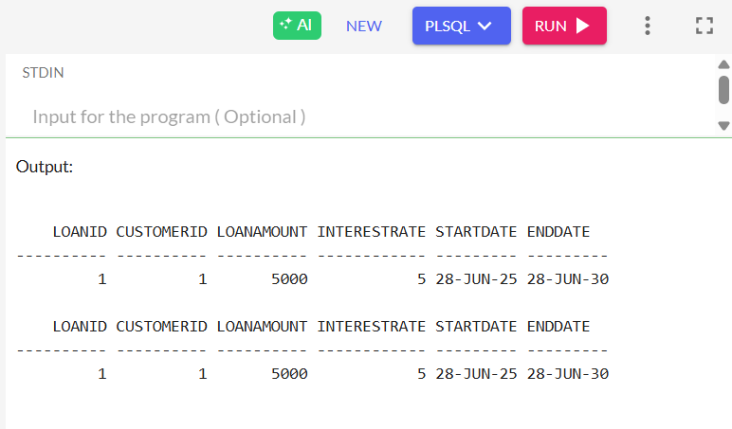

**Scenario 2:** A customer can be promoted to VIP status based on their balance.

* + **Question:** Write a PL/SQL block that iterates through all customers and sets a flag IsVIP to TRUE for those with a balance over $10,000.

**Program:**

CREATE TABLE Customers (

CustomerID NUMBER PRIMARY KEY,

Name VARCHAR2(100),

DOB DATE,

Balance NUMBER,

LastModified DATE,

IsVIP VARCHAR2(5)

);

INSERT INTO Customers (CustomerID, Name, DOB, Balance, LastModified, IsVIP)

VALUES (1, 'John Doe', TO_DATE('1985-05-15', 'YYYY-MM-DD'), 1000, SYSDATE, NULL);

INSERT INTO Customers (CustomerID, Name, DOB, Balance, LastModified, IsVIP)

VALUES (2, 'Jane Smith', TO_DATE('1990-07-20', 'YYYY-MM-DD'), 1500, SYSDATE, NULL);

BEGIN

FOR cust IN (SELECT CustomerID, Balance FROM Customers) LOOP

IF cust.Balance > 10000 THEN

UPDATE Customers

SET IsVIP = 'TRUE'

WHERE CustomerID = cust.CustomerID;

ELSE

UPDATE Customers

SET IsVIP = 'FALSE'

WHERE CustomerID = cust.CustomerID;

END IF;

END LOOP;

END;

/

SELECT CustomerID, Name, Balance, IsVIP FROM Customers;

**Output:**

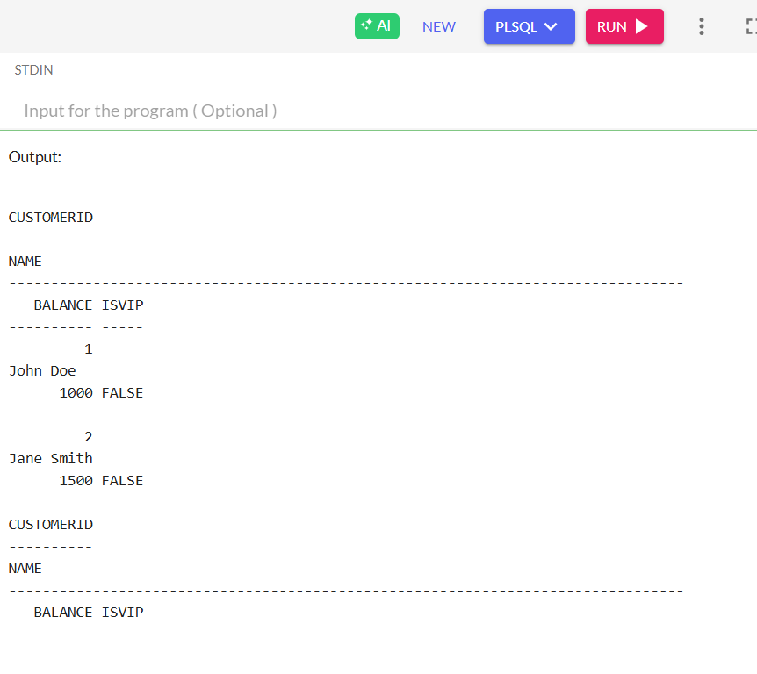

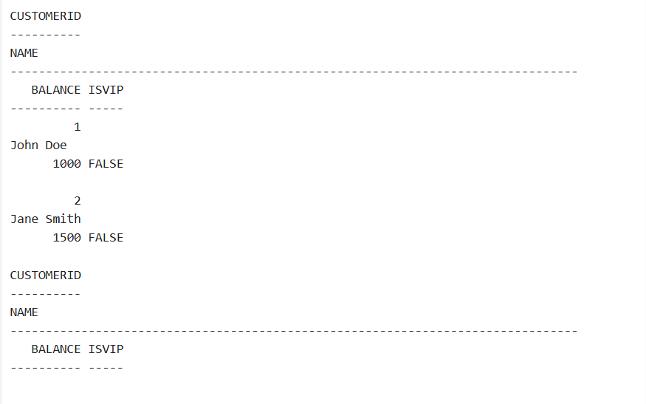

**Scenario 3:** The bank wants to send reminders to customers whose loans are due within the next 30 days.

* + **Question:** Write a PL/SQL block that fetches all loans due in the next 30 days and prints a reminder message for each customer.

**Program:**

CREATE TABLE Customers (

CustomerID NUMBER PRIMARY KEY,

Name VARCHAR2(100),

DOB DATE,

Balance NUMBER,

LastModified DATE

);

CREATE TABLE Loans (

LoanID NUMBER PRIMARY KEY,

CustomerID NUMBER,

LoanAmount NUMBER,

InterestRate NUMBER,

StartDate DATE,

EndDate DATE,

FOREIGN KEY (CustomerID) REFERENCES Customers(CustomerID)

);

INSERT INTO Customers (CustomerID, Name, DOB, Balance, LastModified)

VALUES (1, 'John Doe', TO_DATE('1985-05-15', 'YYYY-MM-DD'), 1000, SYSDATE);

INSERT INTO Customers (CustomerID, Name, DOB, Balance, LastModified)

VALUES (2, 'Jane Smith', TO_DATE('1990-07-20', 'YYYY-MM-DD'), 1500, SYSDATE);

INSERT INTO Loans (LoanID, CustomerID, LoanAmount, InterestRate, StartDate, EndDate)

VALUES (1, 1, 5000, 5, SYSDATE, ADD_MONTHS(SYSDATE, 60));

INSERT INTO Loans (LoanID, CustomerID, LoanAmount, InterestRate, StartDate, EndDate)

VALUES (2, 2, 8000, 6, SYSDATE, SYSDATE + 10);

SET SERVEROUTPUT ON;

BEGIN

FOR loan_rec IN (

SELECT l.LoanID, c.Name, l.EndDate

FROM Loans l

JOIN Customers c ON l.CustomerID = c.CustomerID

WHERE l.EndDate BETWEEN SYSDATE AND SYSDATE + 30

) LOOP

DBMS_OUTPUT.PUT_LINE('Reminder: Loan ID ' || loan_rec.LoanID ||

' for customer ' || loan_rec.Name ||

' is due on ' || TO_CHAR(loan_rec.EndDate, 'DD-MON-YYYY'));

END LOOP;

END;

/

**Output:**

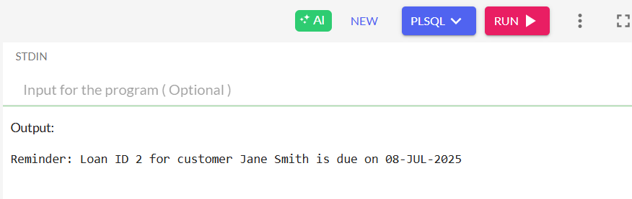

**Exercise 3: Stored Procedures**

**Scenario 1:** The bank needs to process monthly interest for all savings accounts.

* + **Question:** Write a stored procedure **ProcessMonthlyInterest** that calculates and updates the balance of all savings accounts by applying an interest rate of 1% to the current balance.

**Program:**

BEGIN

EXECUTE IMMEDIATE 'DROP TABLE Accounts';

EXECUTE IMMEDIATE 'DROP TABLE Customers';

EXCEPTION

WHEN OTHERS THEN NULL;

END;

/

CREATE TABLE Customers (

CustomerID NUMBER PRIMARY KEY,

Name VARCHAR2(100),

DOB DATE,

Balance NUMBER,

LastModified DATE

);

CREATE TABLE Accounts (

AccountID NUMBER PRIMARY KEY,

CustomerID NUMBER,

AccountType VARCHAR2(20),

Balance NUMBER,

LastModified DATE,

FOREIGN KEY (CustomerID) REFERENCES Customers(CustomerID)

);

INSERT INTO Customers (CustomerID, Name, DOB, Balance, LastModified)

VALUES (1, 'John Doe', TO_DATE('1985-05-15', 'YYYY-MM-DD'), 1000, SYSDATE);

INSERT INTO Customers (CustomerID, Name, DOB, Balance, LastModified)

VALUES (2, 'Jane Smith', TO_DATE('1990-07-20', 'YYYY-MM-DD'), 1500, SYSDATE);

INSERT INTO Accounts (AccountID, CustomerID, AccountType, Balance, LastModified)

VALUES (1, 1, 'Savings', 1000, SYSDATE);

INSERT INTO Accounts (AccountID, CustomerID, AccountType, Balance, LastModified)

VALUES (2, 2, 'Checking', 1500, SYSDATE);

CREATE OR REPLACE PROCEDURE ProcessMonthlyInterest AS

BEGIN

UPDATE Accounts

SET Balance = Balance + (Balance * 0.01)

WHERE AccountType = 'Savings';

COMMIT;

END;

/

SET SERVEROUTPUT ON;

BEGIN

DBMS_OUTPUT.PUT_LINE('Before interest update:');

FOR acc IN (SELECT * FROM Accounts) LOOP

DBMS_OUTPUT.PUT_LINE('AccountID: ' || acc.AccountID || ', Type: ' || acc.AccountType || ', Balance: ' || acc.Balance);

END LOOP;

ProcessMonthlyInterest;

DBMS_OUTPUT.PUT_LINE('After interest update:');

FOR acc IN (SELECT * FROM Accounts) LOOP

DBMS_OUTPUT.PUT_LINE('AccountID: ' || acc.AccountID || ', Type: ' || acc.AccountType || ', Balance: ' || acc.Balance);

END LOOP;

END;

/

**Output:**

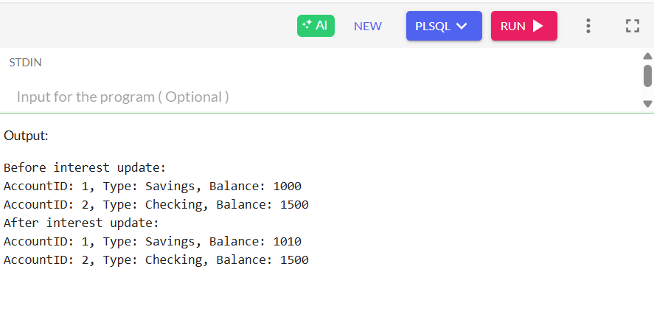

**Scenario 2:** The bank wants to implement a bonus scheme for employees based on their performance.

* + **Question:** Write a stored procedure **UpdateEmployeeBonus** that updates the salary of employees in a given department by adding a bonus percentage passed as a parameter.

**Program:**

BEGIN

EXECUTE IMMEDIATE 'DROP TABLE Employees';

EXCEPTION

WHEN OTHERS THEN NULL;

END;

/

CREATE TABLE Employees (

EmployeeID NUMBER PRIMARY KEY,

Name VARCHAR2(100),

Position VARCHAR2(50),

Salary NUMBER,

Department VARCHAR2(50),

HireDate DATE

);

INSERT INTO Employees (EmployeeID, Name, Position, Salary, Department, HireDate)

VALUES (1, 'Alice Johnson', 'Manager', 70000, 'HR', TO_DATE('2015-06-15', 'YYYY-MM-DD'));

INSERT INTO Employees (EmployeeID, Name, Position, Salary, Department, HireDate)

VALUES (2, 'Bob Brown', 'Developer', 60000, 'IT', TO_DATE('2017-03-20', 'YYYY-MM-DD'));

CREATE OR REPLACE PROCEDURE UpdateEmployeeBonus (

p_department IN VARCHAR2,

p_bonus_percent IN NUMBER

) AS

BEGIN

UPDATE Employees

SET Salary = Salary + (Salary * p_bonus_percent / 100)

WHERE Department = p_department;

COMMIT;

END;

/

SET SERVEROUTPUT ON;

BEGIN

DBMS_OUTPUT.PUT_LINE('Before Bonus:');

FOR r IN (SELECT * FROM Employees) LOOP

DBMS_OUTPUT.PUT_LINE('Name: ' || r.Name || ', Department: ' || r.Department || ', Salary: ' || r.Salary);

END LOOP;

UpdateEmployeeBonus('IT', 10);

DBMS_OUTPUT.PUT_LINE('After Bonus:');

FOR r IN (SELECT * FROM Employees) LOOP

DBMS_OUTPUT.PUT_LINE('Name: ' || r.Name || ', Department: ' || r.Department || ', Salary: ' || r.Salary);

END LOOP;

END;

/

**Output:**

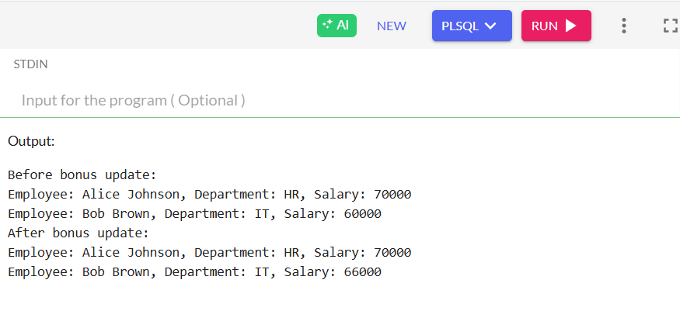

**Scenario 3:** Customers should be able to transfer funds between their accounts.

* + **Question:** Write a stored procedure **TransferFunds** that transfers a specified amount from one account to another, checking that the source account has sufficient balance before making the transfer.

**Program:**

BEGIN

EXECUTE IMMEDIATE 'DROP TABLE Accounts';

EXECUTE IMMEDIATE 'DROP TABLE Customers';

EXCEPTION

WHEN OTHERS THEN NULL;

END;

/

CREATE TABLE Customers (

CustomerID NUMBER PRIMARY KEY,

Name VARCHAR2(100),

DOB DATE,

Balance NUMBER,

LastModified DATE

);

CREATE TABLE Accounts (

AccountID NUMBER PRIMARY KEY,

CustomerID NUMBER,

AccountType VARCHAR2(20),

Balance NUMBER,

LastModified DATE,

FOREIGN KEY (CustomerID) REFERENCES Customers(CustomerID)

);

INSERT INTO Customers (CustomerID, Name, DOB, Balance, LastModified)

VALUES (1, 'John Doe', TO_DATE('1985-05-15', 'YYYY-MM-DD'), 1000, SYSDATE);

INSERT INTO Customers (CustomerID, Name, DOB, Balance, LastModified)

VALUES (2, 'Jane Smith', TO_DATE('1990-07-20', 'YYYY-MM-DD'), 1500, SYSDATE);

INSERT INTO Accounts (AccountID, CustomerID, AccountType, Balance, LastModified)

VALUES (1, 1, 'Savings', 1000, SYSDATE);

INSERT INTO Accounts (AccountID, CustomerID, AccountType, Balance, LastModified)

VALUES (2, 2, 'Checking', 1500, SYSDATE);

CREATE OR REPLACE PROCEDURE TransferFunds (

p_source_account IN NUMBER,

p_dest_account IN NUMBER,

p_amount IN NUMBER

) AS

v_source_balance NUMBER;

BEGIN

SELECT Balance INTO v_source_balance FROM Accounts WHERE AccountID = p_source_account FOR UPDATE;

IF v_source_balance < p_amount THEN

RAISE_APPLICATION_ERROR(-20001, 'Insufficient funds in source account.');

END IF;

UPDATE Accounts

SET Balance = Balance - p_amount

WHERE AccountID = p_source_account;

UPDATE Accounts

SET Balance = Balance + p_amount

WHERE AccountID = p_dest_account;

COMMIT;

END;

/

SET SERVEROUTPUT ON;

BEGIN

DBMS_OUTPUT.PUT_LINE('Before transfer:');

FOR r IN (SELECT * FROM Accounts) LOOP

DBMS_OUTPUT.PUT_LINE('AccountID: ' || r.AccountID || ', Balance: ' || r.Balance);

END LOOP;

TransferFunds(1, 2, 500);

DBMS_OUTPUT.PUT_LINE('After transfer:');

FOR r IN (SELECT * FROM Accounts) LOOP

DBMS_OUTPUT.PUT_LINE('AccountID: ' || r.AccountID || ', Balance: ' || r.Balance);

END LOOP;

END;

/

**Output:**

